
(An off-Campus Institution of NITTE (DEEMED TO BE UNIVERSITY), MANGALORE)
Department of MCA

07-04-2026
ADVANCED WEB TECHNOLOGIES LAB ASSIGNMENT 6

1. Write a JavaScript program that tracks user interaction with a textbox using: focus, blur, change, key up. Display the event logs dynamically on the webpage.

<!DOCTYPE html>
<html>

<body>

<input id="box" placeholder="Type something...">
<ul id="log"></ul>

<script>
const box = document.getElementById("box"),
log = document.getElementById("log");

function add(e) {
log.innerHTML = `<li>${e.type} : ${box.value}</li>` + log.innerHTML;
}

["focus", "blur", "change", "keyup"].forEach(ev =>
box.addEventListener(ev, add)
);
</script>

</body>

</html>

Output:
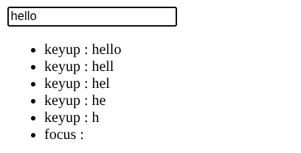

2. Write a JavaScript program that accepts a paragraph in a text area and allows the user to:

i. Search a word or pattern

ii. Count occurrences

iii. Replace the word with another word

iv. Use regular expressions, string methods, and DOM manipulation.

<!DOCTYPE html>
<html>

<body>

<textarea id="txt" rows="6" cols="50" placeholder="Enter paragraph..."></textarea><br><br>

<input id="find" placeholder="Search / Pattern">
<input id="rep" placeholder="Replace with">
<label><input type="checkbox" id="useRegex"> Use Regex</label>
<button onclick="run()">Run</button>

<p id="out"></p>

<script>
function run() {
let t = document.getElementById("txt").value,
f = document.getElementById("find").value,
r = document.getElementById("rep").value,
useRegex = document.getElementById("useRegex").checked;

if (!f) {
document.getElementById("out").innerHTML = "Enter search text";
return;
}

let re;
try {
// if not regex mode → escape input
let pattern = useRegex ? f : f.replace(/[.*+?^${}()|[\]\\]/g, "\\$&");
re = new RegExp(pattern, "gi");
} catch (e) {
document.getElementById("out").innerHTML = "Invalid pattern";
return;
}

let matches = t.match(re),
count = matches ? matches.length : 0,
replaced = t.replace(re, r);

document.getElementById("out").innerHTML =
"Count: " + count + "<br><br>" +
"Replaced:<br>" + replaced;
}
</script>

</body>

</html>

Output:
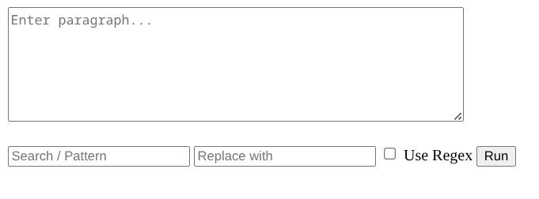
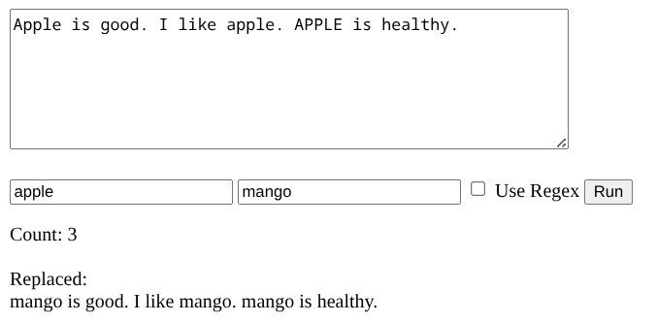

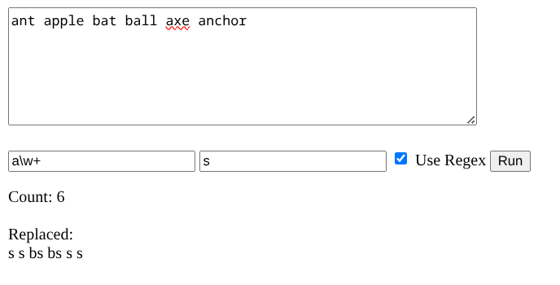

3. Using an implicit array, display the number of checkboxes related to grocery items to be purchased have been checked.

<!DOCTYPE html>
<html>

<body>

<form>
<label><input type="checkbox" name="g"> Rice</label>
<label><input type="checkbox" name="g"> Milk</label>
<label><input type="checkbox" name="g"> Eggs</label>
<label><input type="checkbox" name="g"> Bread</label><br><br>

<button type="button" onclick="count(this)">Count Checked</button>
</form>

<p id="out"></p>

<script>
function count(btn) {
let c = 0, items = btn.form.elements; // implicit array
for (let i = 0; i < items.length; i++)
if (items[i].type == "checkbox" && items[i].checked) c++;

out.innerHTML = "Checked items: " + c;
}
</script>

</body>

</html>

Output:
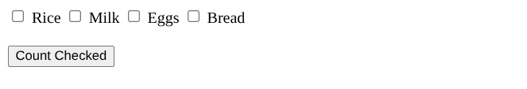
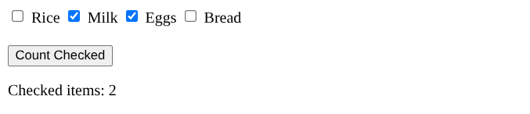
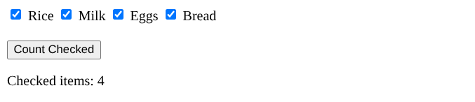

4. Create an HTML document that includes five radio buttons, labelled red, blue, green, yellow, and orange. The event handlers for these buttons must produce messages stating the chosen favourite color. The event handler must be implemented as a function whose name must be assigned to the onclick attribute of the radio button elements. The chosen color must be sent to the event handler as a parameter.

<!DOCTYPE html>
<html>

<body>

<p>Select your favourite color:</p>

<label><input type="radio" name="c" onclick="show('Red')"> Red</label>
<label><input type="radio" name="c" onclick="show('Blue')"> Blue</label>
<label><input type="radio" name="c" onclick="show('Green')"> Green</label>
<label><input type="radio" name="c" onclick="show('Yellow')"> Yellow</label>
<label><input type="radio" name="c" onclick="show('Orange')"> Orange</label>

<p id="out"></p>

<script>
function show(color) {
out.innerHTML = "Your favourite color is " + color;
}
</script>

</body>

</html>

Output:
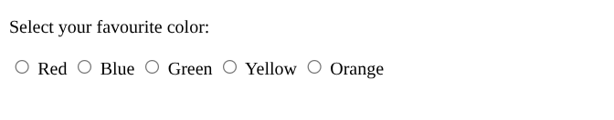
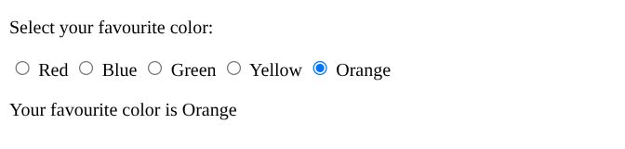
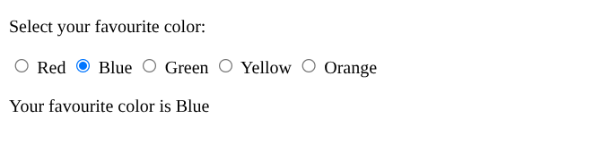

5. Rewrite the above exercise to handle the events using DOM2 event model.

<!DOCTYPE html>
<html>

<body>

<p>Select your favourite color:</p>

<label><input type="radio" name="c" value="Red"> Red</label>
<label><input type="radio" name="c" value="Blue"> Blue</label>
<label><input type="radio" name="c" value="Green"> Green</label>
<label><input type="radio" name="c" value="Yellow"> Yellow</label>
<label><input type="radio" name="c" value="Orange"> Orange</label>

<p id="out"></p>

<script>
const radios = document.getElementsByName("c");

function show(color) {
out.innerHTML = "Your favourite color is " + color;
}

radios.forEach(r =>
r.addEventListener("click", () => show(r.value))
);
</script>

</body>

</html>

Output:
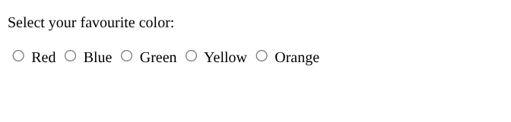
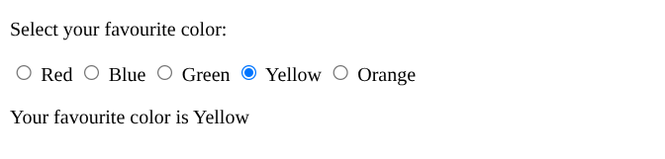

6. Create a JavaScript for the following: When a page is loaded, it should display ‘Welcome to the Computation page’ in an alert; then two numbers are provided in text boxes (Validate that they are numbers-if nonnumeric value is displayed, appropriate message should be displayed). In another text box, provide an operation to be carried out in the form of symbols (+,-,*,/,%). Validate this entry also. Include a button ‘Compute’ which when clicked, corresponding arithmetic operation should be carried out and result should be displayed in a text box(which should not be allowed to edit)

<!DOCTYPE html>
<html>
<body onload="alert('Welcome to the Computation page')">

<input id="n1" placeholder="Number 1">
<input id="n2" placeholder="Number 2">
<input id="op" placeholder="+ - * / %">
<button onclick="calc()">Compute</button><br><br>

<input id="res" placeholder="Result" readonly>
<p id="msg"></p>

<script>
function calc(){
let a = n1.value, b = n2.value, o = op.value.trim();

if(isNaN(a) || isNaN(b) || a=="" || b=="")
return msg.innerHTML = "Enter valid numbers";

if(!["+","-","*","/","%"].includes(o))
return msg.innerHTML = "Invalid operator";

a = +a; b = +b;
let r = {"+":a+b,"-":a-b,"*":a*b,"/":a/b,"%":a%b}[o];

res.value = r;
msg.innerHTML = "";
}
</script>

</body>
</html>

Output:
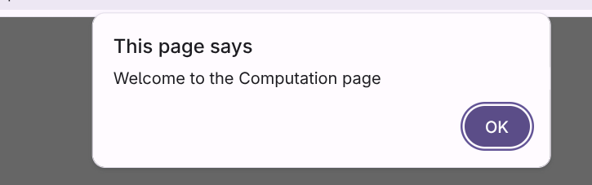
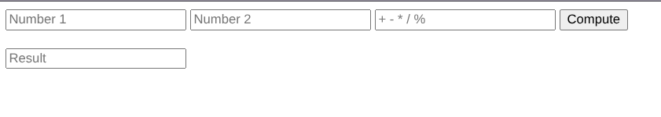
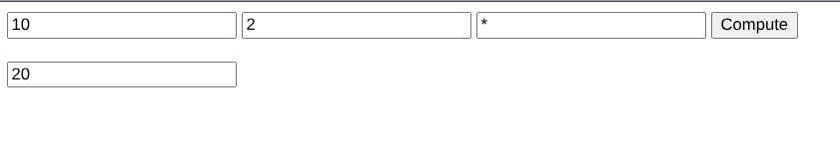
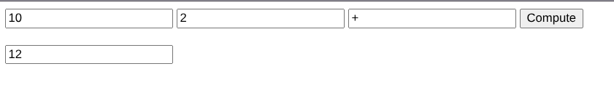
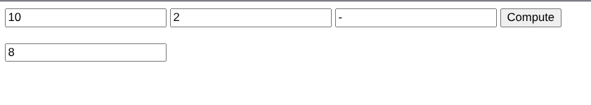
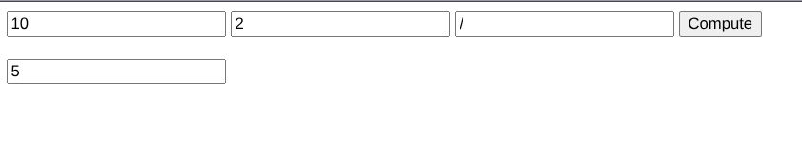
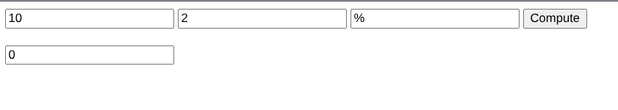

7. Show the concept of event propagation in JavaScript event handling.

<!DOCTYPE html>
<html>

<body>

<div id="outer" style="padding:40px; background:lightblue;">
OUTER
<div id="middle" style="padding:30px; background:lightgreen;">
MIDDLE
<div id="inner" style="padding:20px; background:lightcoral;">
INNER (Click Me)
</div>
</div>
</div>

<p id="log"></p>

<script>
function show(msg) {
log.innerHTML += msg + "<br>";
}

// Bubbling (default)
outer.addEventListener("click", () => show("Outer Bubble"));
middle.addEventListener("click", () => show("Middle Bubble"));
inner.addEventListener("click", () => show("Inner Bubble"));

// Capturing
outer.addEventListener("click", () => show("Outer Capture"), true);
middle.addEventListener("click", () => show("Middle Capture"), true);
inner.addEventListener("click", () => show("Inner Capture"), true);
</script>

</body>

</html>

Output:
